OBJECTIVES ___Chapter 5: Section 5.6, The Law of Cosines (Pages 435 – 440).
- Know that an oblique triangle is a triangle that does not contain a right angle.
- Understand The Triangle Inequality Theorem: The sum of the lengths of any two sides of a triangle must be greater than the third side.
- Use the Law of Cosines to solve a right triangle or an oblique triangle when given SAS or SSS.
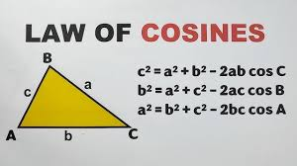
- Be able to find the areas of both right and oblique triangles.
- Use Area = 0.5(base)(height) for right triangles and oblique triangles when you know the base and the height.
- Use The Law of Sines Area Formula for oblique triangles when you know 2 sides and an included angle (SAS).
- Use Hero’s (Heron’s) Formula when you know all 3 sides (SSS).
- Use the Law of Sines when you know AAS, ASA, and SSA (the Ambiguous Case. (Pages 427 – 431)
- 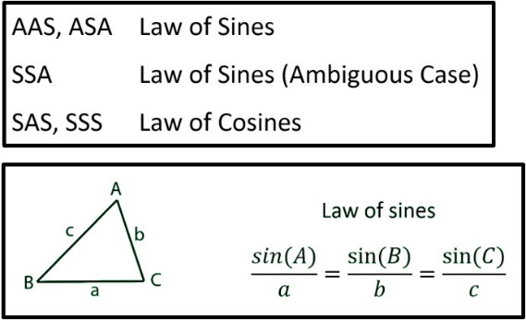
TUESDAY (4.8.25)
WIN TESTING FOR JUNIORS AND SELECT SENIORS
Review The Law of Sines. Use when given AAS, ASA, SSA (the ambiguous case).
Do you have any questions about the work assigned previously?
- Page 432, #2, 10, 16.
- Page 432, #1, 3, 11, 13.
Class Work/Homework: Pages 432, 433, #37, 39, 43, 44.
THURSDAY 4.10.25)
Discuss the previously assigned work: Pages 432, 433, #37, 39, 43, 44.
Class Work/Homework: Review the Law of Sines for a test on Tuesday, April 15.

FRIDAY (4.11.25)
Discuss the previously assigned work: The Law of Sines Review for a test on Tuesday, April 15. You may use one sheet of paper, 8.5 by 11 inches, front and back, when you take this test on Tuesday, April 15.

